\*Note, this Clario workflow is similar to the InteleViewer workflow

Open Clario website <https://swl.riaco.com> or click the app from the desktop.

1. Log in with RIA logon (20-character password for each desktop).
2. 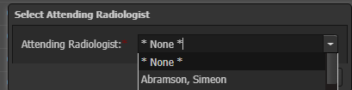Once first opened, CLARIO will ask you for an attending, choose \*none\* at the top of the list and then click save.
3. Clario will now launch Inteleviewer (IV) and Powerscribe 360 (PS360) for you.
4. A screenshot of a computer

   Description automatically generatedOnce launched, find your exams by "Other Worklists" in the far-left column. 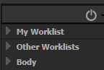
5. Next click “DEXA – Unread” to proceed with drafting.

1. Launch each examination using the Read icon
2. This is where Clario links and activates your IV and PS360.
3. On the first draft, PS360 will ask you to choose an attending for the day. Click “Unassigned” on and include the check box right below, which is unchanged from the old workflow.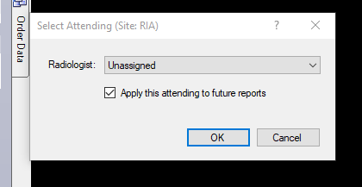
4. When you are finished drafting, click "correct", not draft, on the top of PS360.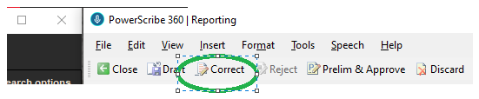
5. Draft is for incomplete drafts if you are busy and juggling multiple cases.
6. After "Correct" it will close your IV and close your PS360 for you.
7. It may ask you to spell check your exam, you can spellcheck or click ignore all.
8. It may ask you to click YES here: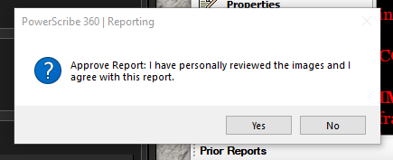
9. Next you need to maximize your clario page and find “DEXA – Drafted” on the leftmost column of Clario. 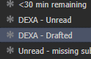
10. Here, you will be able to find the patient that you just drafted into PS360.
11. Now you need to unlock your exam by clicking the Padlock icon to unlock it. This will immediately remove the green icon of a person from the exam.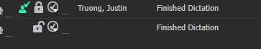
12. Now that you’ve unlocked the padlock, any breast radiologist can sign the dexa whenever they have time.

MISC.

Sort your list so indicators tab is visible (this will prevent you from picking up exams that have issues)

